Goldengate Monitor的安装和调试

Goldengate Monitor的安装和调试 1

1 前置任务 2

1.1 软件信息 2

2 安装JDK 1.8 3

3 配置解析 3

4 安装ADR 3

5 确认数据库open，监听start 10

6 安装Monitor Server 10

7 创建RCU 16

7.1 确认字符集 16

8 创建domain 20

9 完成Monitor配置 30

9.1 Configure the JMX Server Properties 30

9.2 输入domain的全路径 30

10 检查配置并启动Weblogic&Monitor服务 31

10.1 启动Weblogic管理员服务器 31

11 创建gg monitor专用用户 32

12 启动Weblogic托管服务 33

13 修改domain端口(可选项) 34

14 安装gg monitor agent 35

15 配置 monitor agent 35

15.1 创建agent实例 35

15.2 修改配置文件 36

15.3 Create Wallet Credentials 37

15.4 注册 agent instance 37

# 前置任务

## 软件信息

**Oggmonitor &Veridadta 12.2.1**

<http://www.oracle.com/technetwork/middleware/goldengate/downloads/index.html>

里面包含有：Veridata Sever, Veridata Agents, Monitor Server, Monitor Agents。  
由于这个版本基于Weblogic 12.2.1.0

**Application Development Runtime(ADR)**

Oracle Application Development Runtime Infrastructure，地址：http://www.oracle.com/technetwork/developer-tools/adf/downloads/index.html

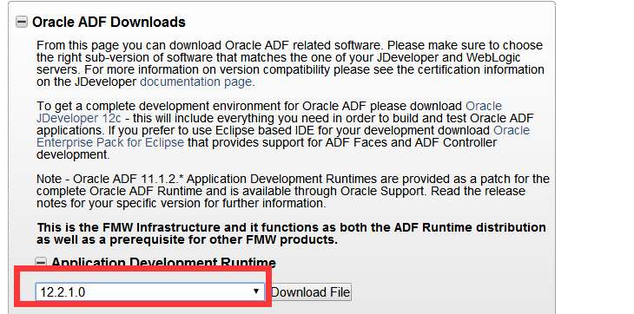

**Jdk1.8**

**http://www.oracle.com/technetwork/java/javase/downloads/jdk8-downloads-2133151.html**

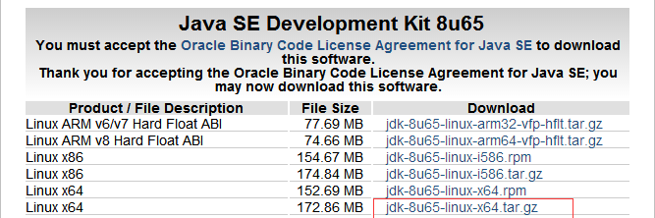

字符集:

Oracle 11g 或 12c （mysql 5.5 、sqlserver 2008,2012）,字符集必须为AL32UTF8

# 安装JDK 1.8

# tar -xzvf jdk-8u65-linux-x64.tar.gz -C /usr/lib

# cd /usr/lib

# mv java java.orig

# ln -s jdk1.8.0_65 java

Root:

Vi /etc/profile

export JAVA_HOME=/usr/lib/java

export JRE_HOME=$JAVA_HOME/jre

export PATH=$JAVA_HOME/bin:$JRE_HOME/bin:$PATH

export CLASSPATH=$JAVA_HOME/lib:$JRE_HOME/lib:$CLASSPATH

source /etc/profile

su – oracle

java –version

# 配置解析

/etc/hosts文件

|  |
| --- |
| 10.9.0.136 oggv.t.com oggv  10.9.0.149 oggs.t.com oggs  10.9.0.155 oggt.t.com oggt |

# 安装ADR

增加配置环境变量

export ORACLE_HOME=$ORACLE_BASE/product/11.2.0/db_1;

export MW_HOME=$ORACLE_BASE/product/12.2.0/middleware

export WLS_HOME=$MW_HOME/wlserver

export WL_HOME=$WLS_HOME

export DOMAIN_BASE=$MW_HOME/user_projects/domains

export DOMAIN_HOME=$DOMAIN_BASE/gm_domain

export PATH=$ORACLE_HOME/bin:$JAVA_HOME/bin:$PATH;

export CLASSPATH=$ORACLE_HOME/jlib:$ORACLE_HOME/rdbms/jlib: $CLASSPATH

$ unzip fmw_12.2.1.0.0_infrastructure_Disk1_1of1.zip

$ java -jar fmw_12.2.1.0.0_infrastructure.jar

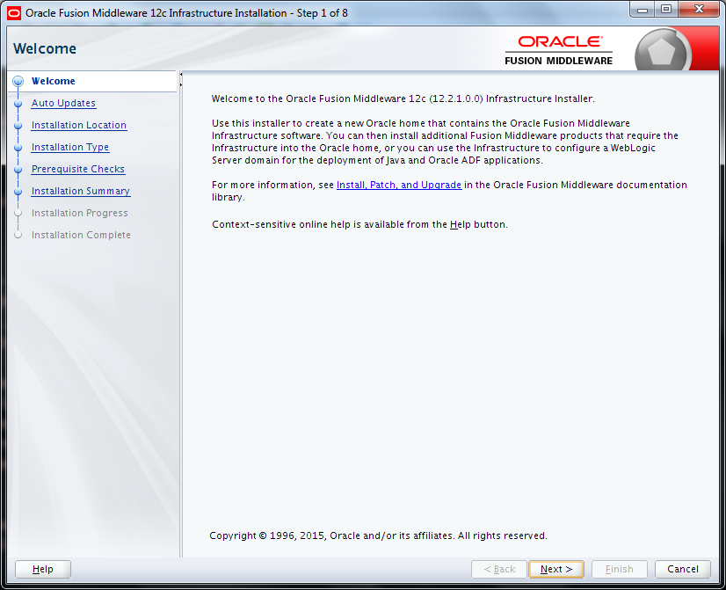

点击Next

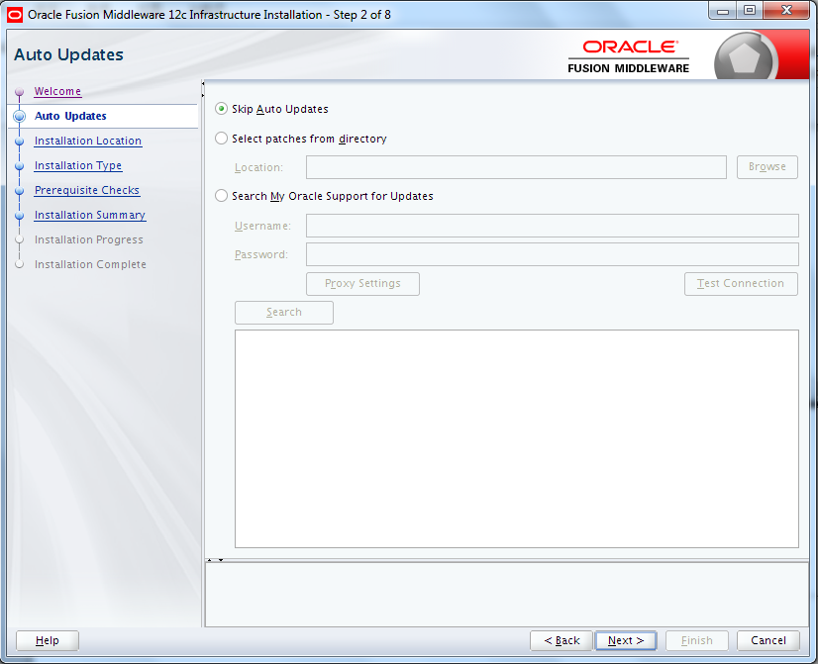

选择跳过更新 点Next

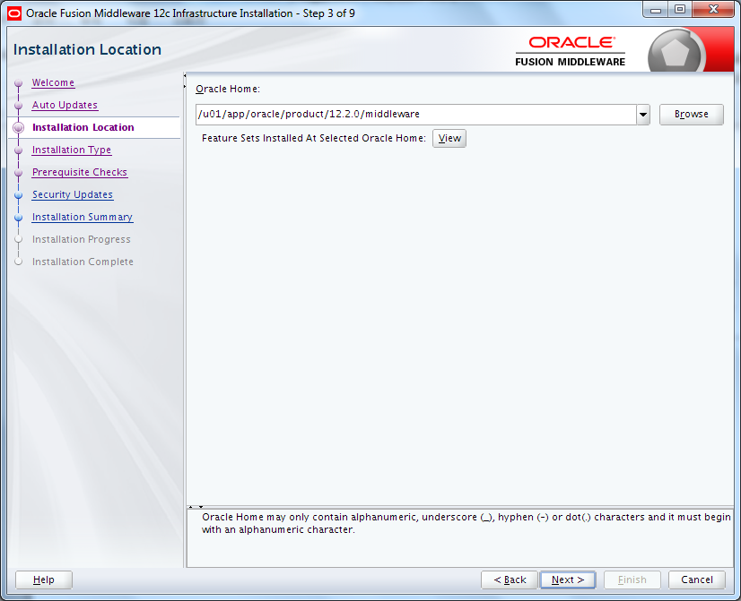

点击Next

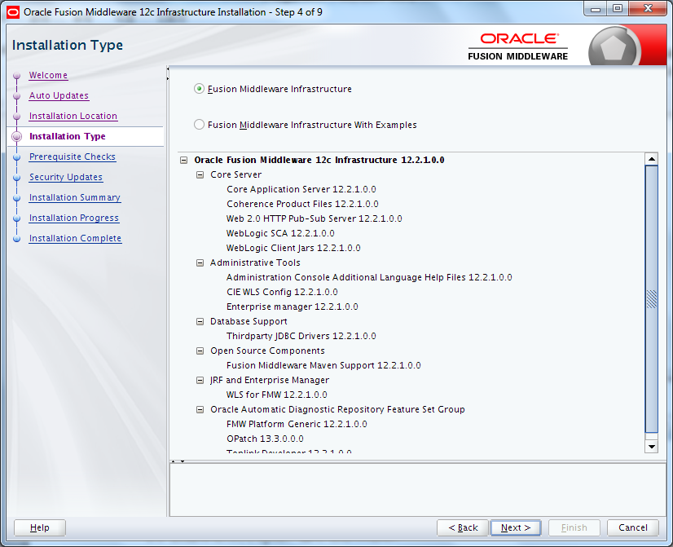

默认选项 ,点击Next

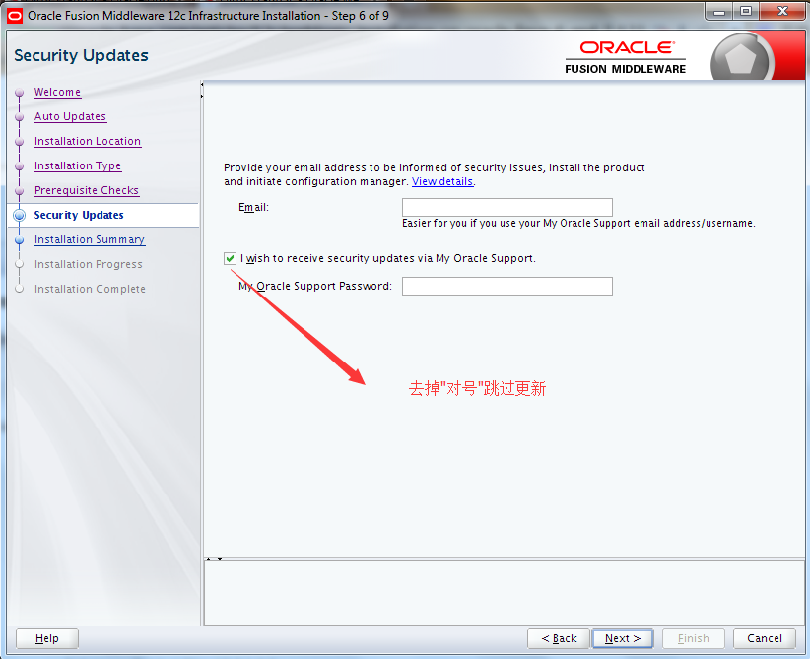

跳过更新 Next

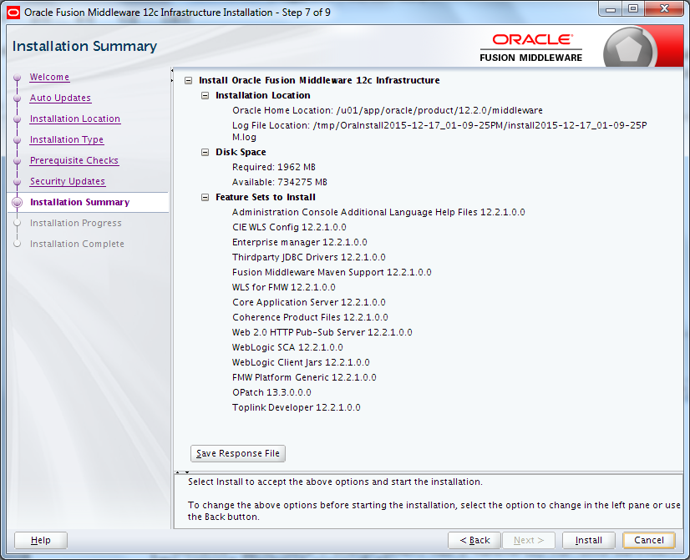

下列安装图借鉴了oracle-base的

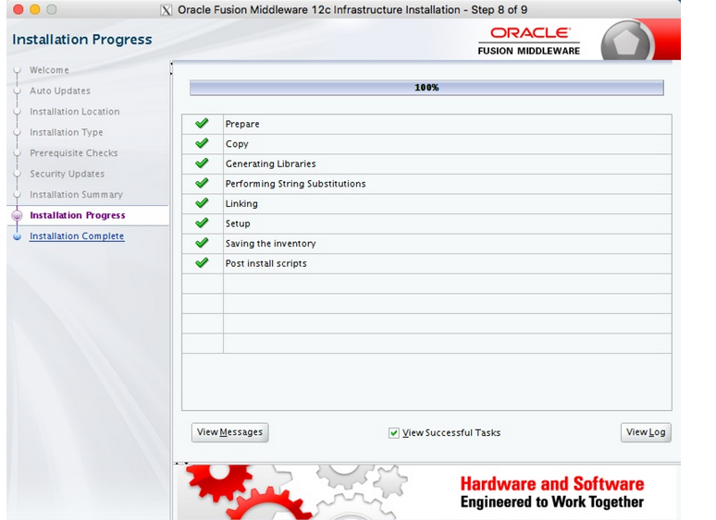

等安装完成点击Next

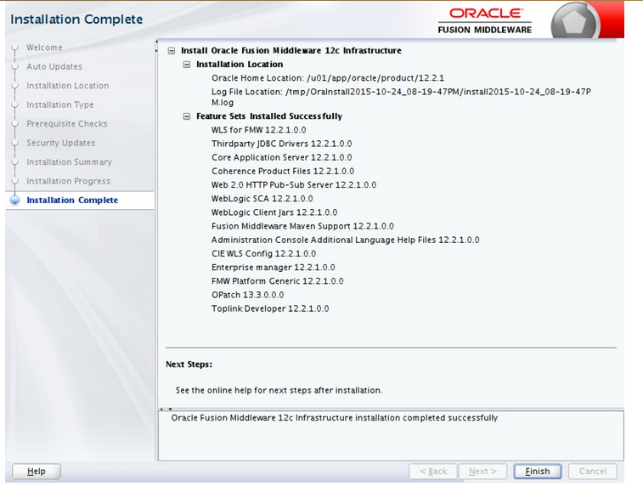

点击Finish 完成install.

# 确认数据库open，监听start

SQL>Select status from v$database;

$ lsnrctl status

# 安装Monitor Server

$ unzip fmw_12.2.1.0.0_ogg_Disk1_1of1.zip

$ java -jar fmw_12.2.1.0.0_ogg.jar

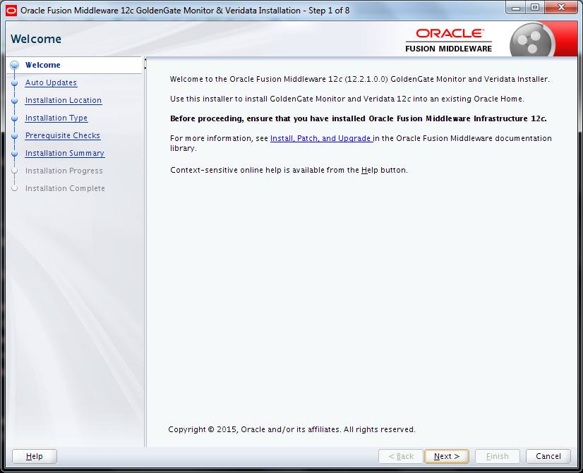

点Next

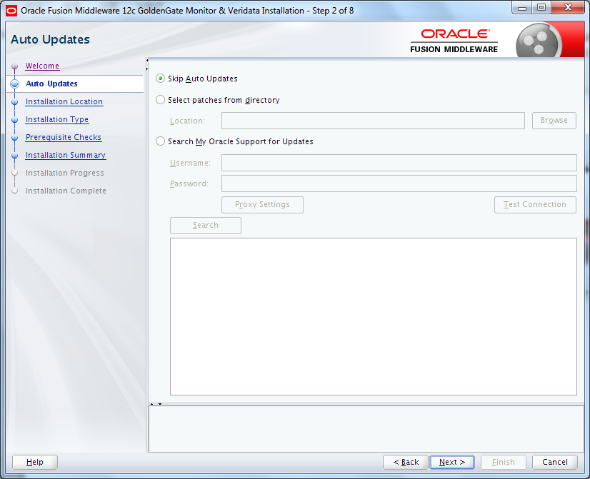

选择跳过更新 点Next

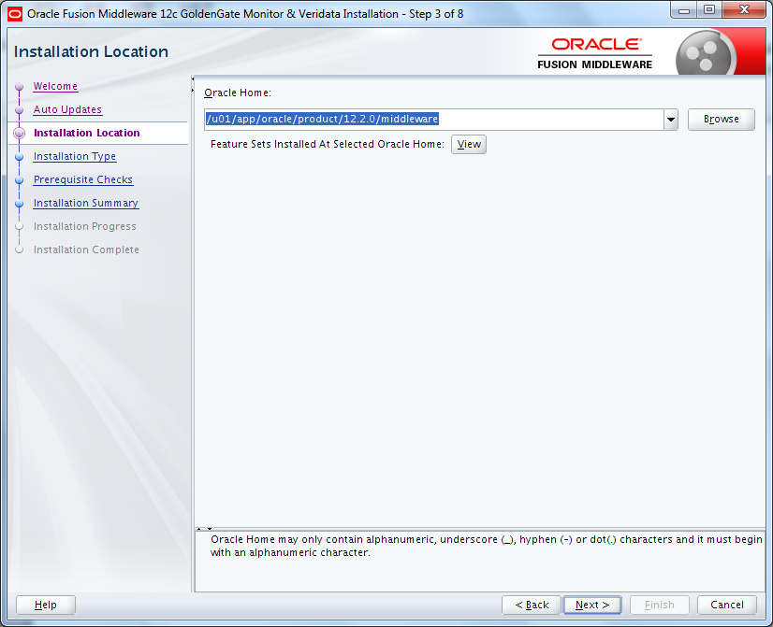

这里的oracle_home 要和ADR的保持一致.Next

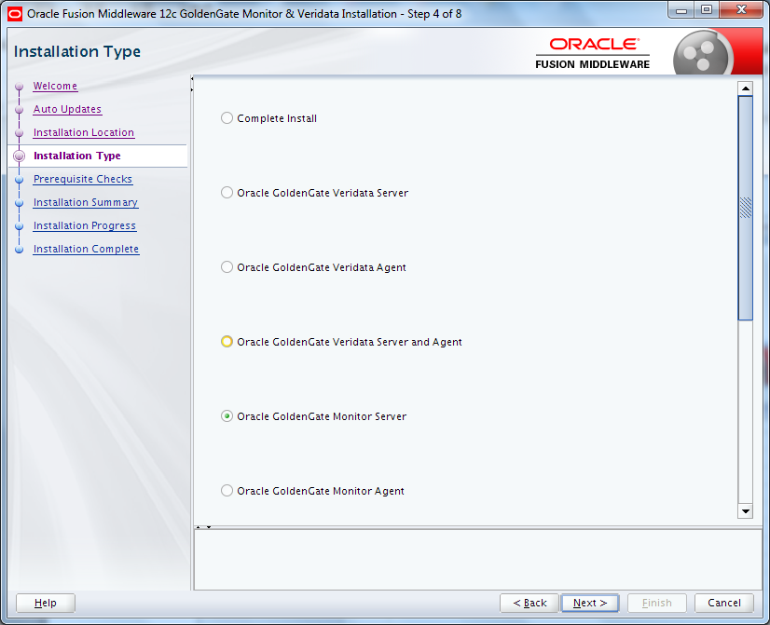

选择 点Next

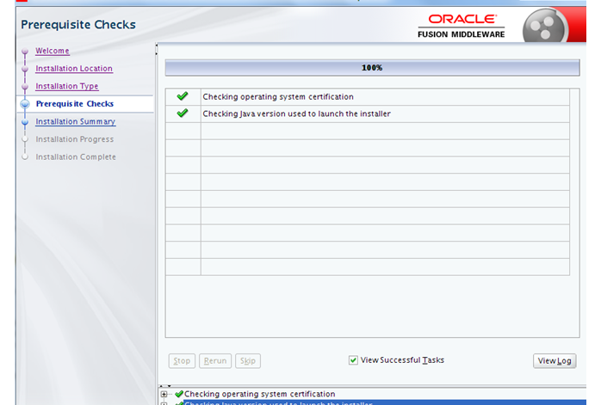

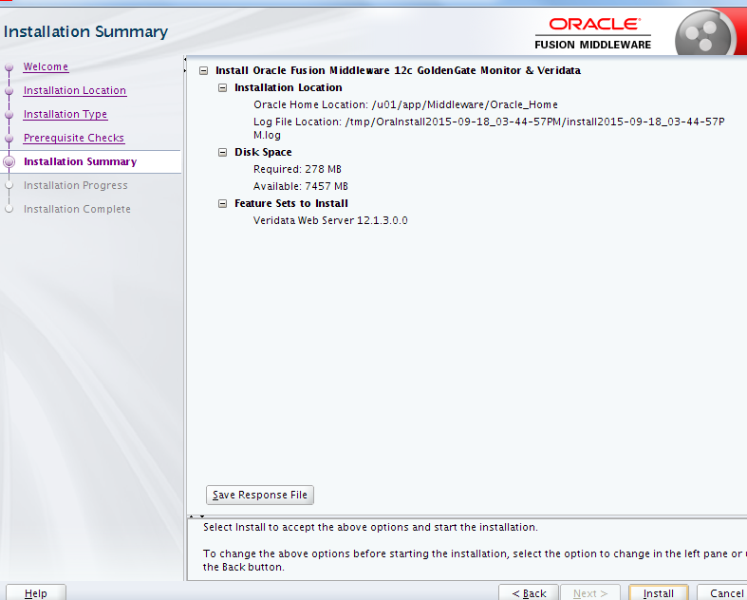

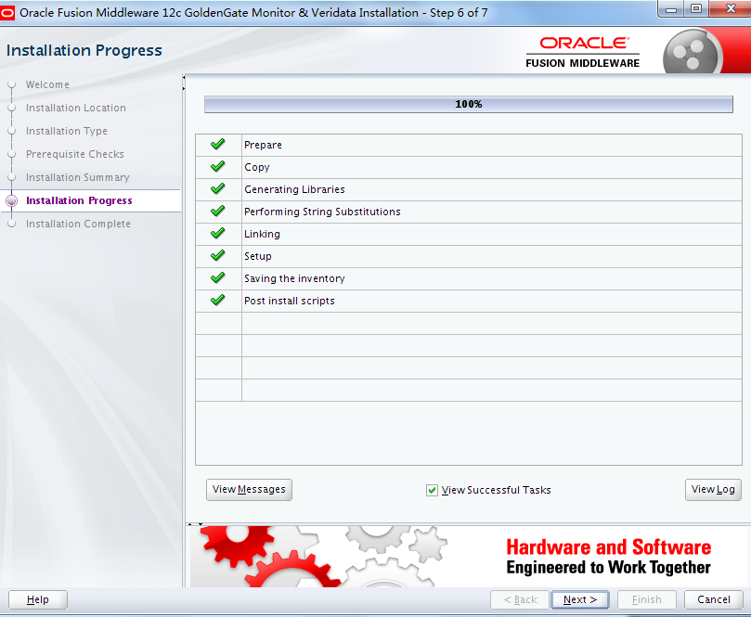

下面就是Next 直到安装完成点Finish

# 创建RCU

## 确认字符集

Col parameter for a30

Col value for a40

SYS@oggv.t.com-oggv> select * from nls_database_parameters where parameter='NLS_CHARACTERSET';

PARAMETER VALUE

----------------- -------------

NLS_CHARACTERSET AL32UTF8

$ cd $MW_HOME/oracle_common/bin

$ ./rcu

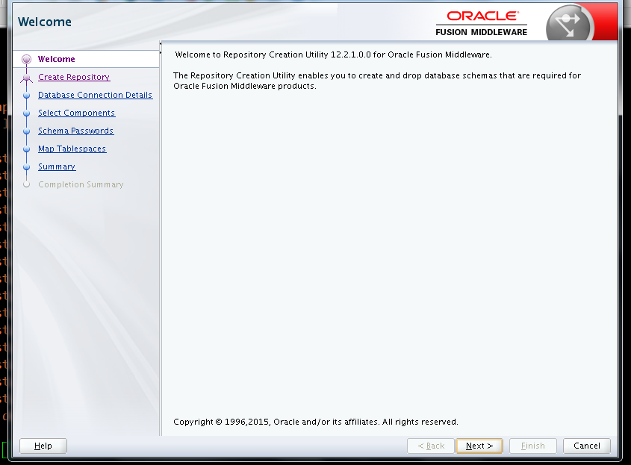

Next

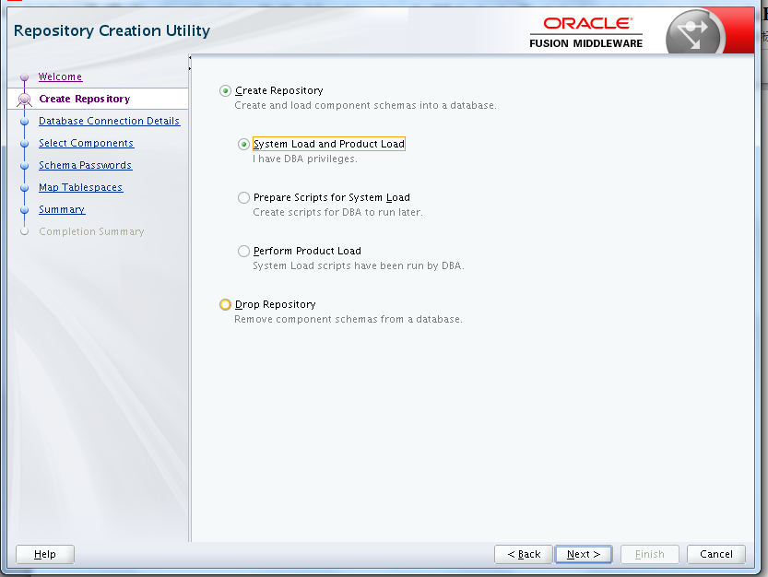

默认选项 Next

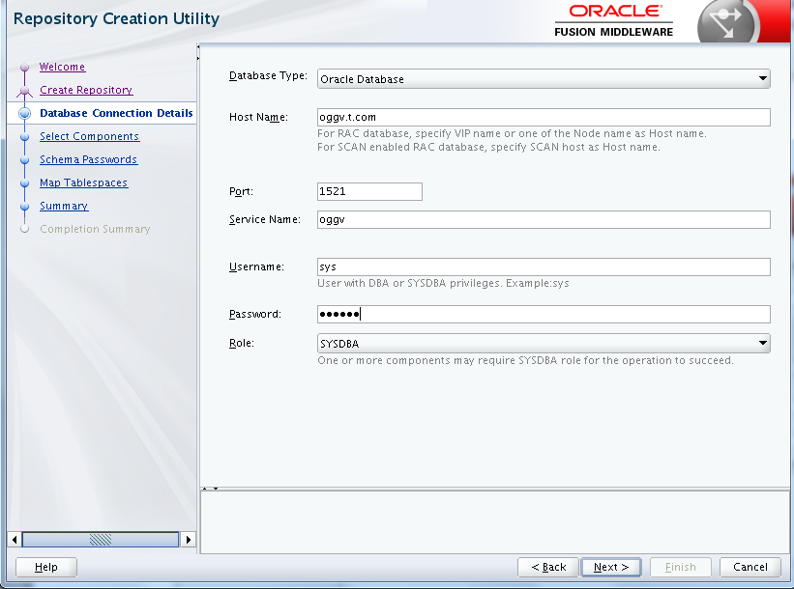

Next

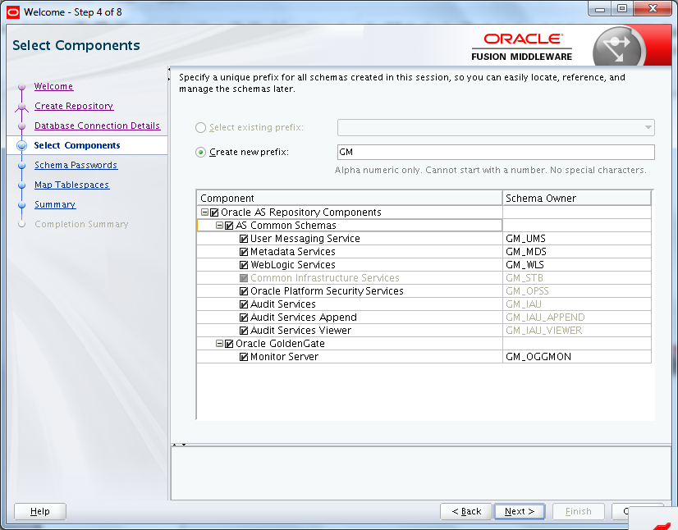

前缀使用gm即(gg Monitor) , Component选择所有,Next

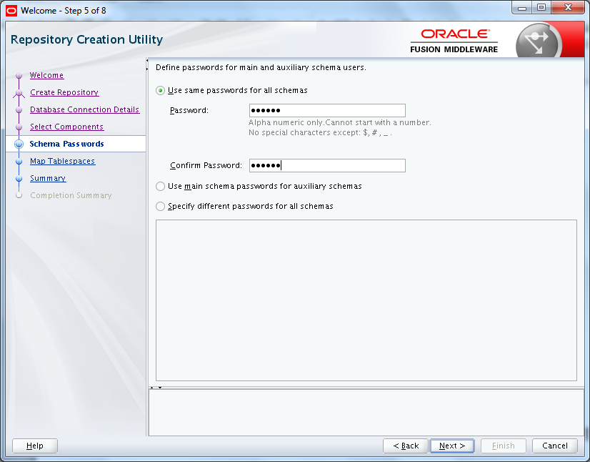

使用相同密码：oracle , Next

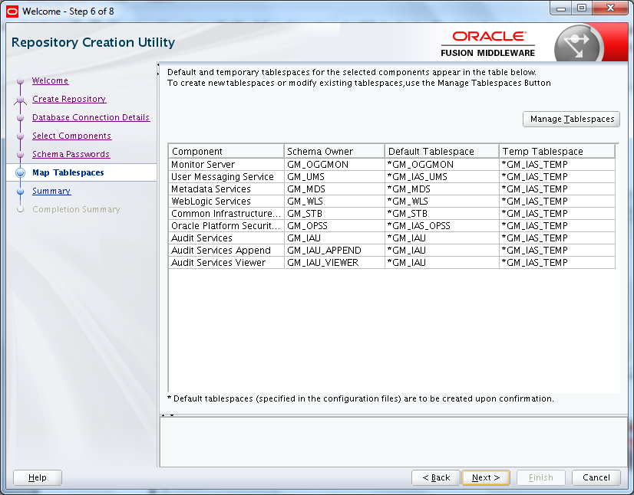

点Next 创建需要的表空间

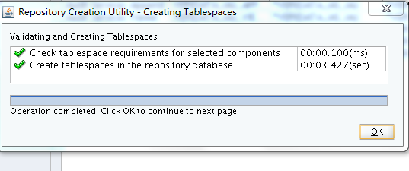

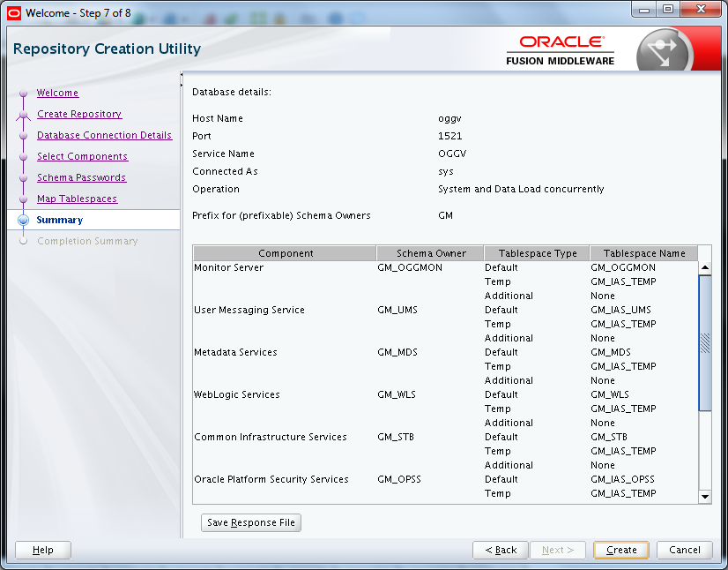

点Create

创建完成后点击Close

# 创建domain

$ cd $MW_HOME/oracle_common/common/bin

修改domain的目录为环境变量配置的DOMAIN_HOME

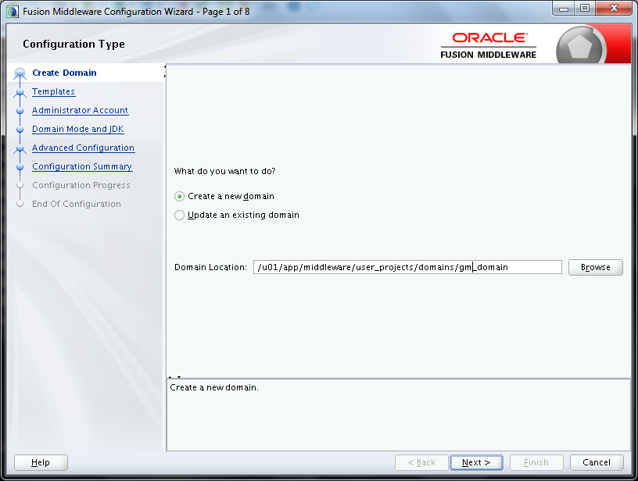

选择 **Oracle GoldenGate Monitor Server Domain-12.2.1 (oggmon)**

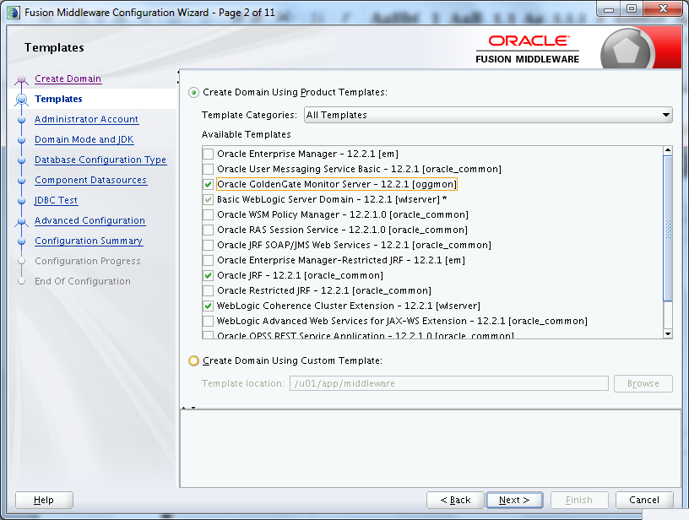

Weblogic密码为：Password1

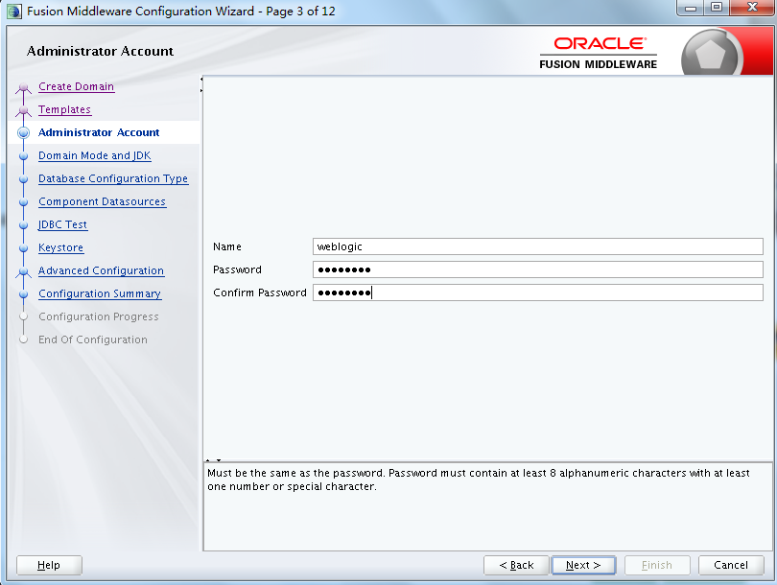

select **Production**.

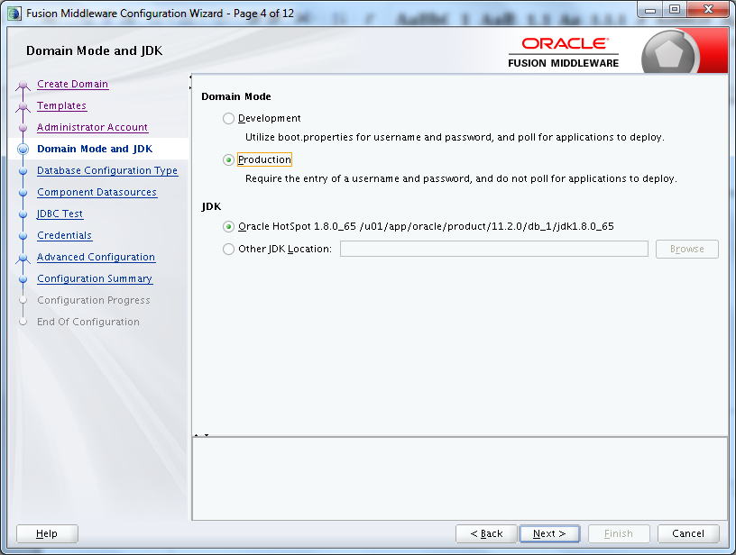

1. Ensure RCU data radio button is selected.Enter the database connection information.
2. Enter the Schema owner, which is the prefix you specified when creating your repository appended with_STB; for example, GM_STB.
3. Enter the Password. "oracle"
4. Click **Get RCU Configuration**.
5. Click **Next**.

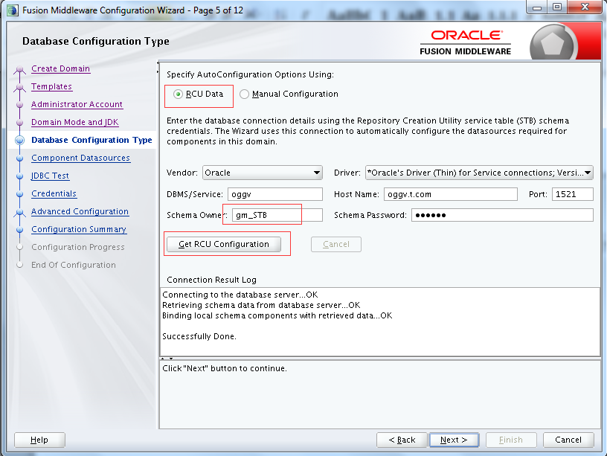

next

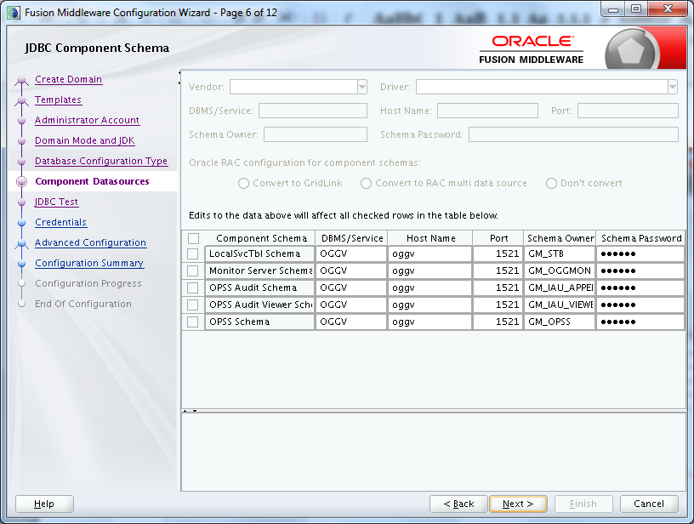

Next

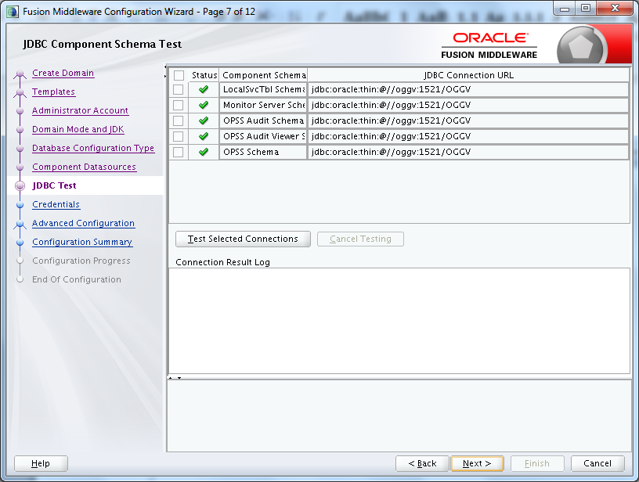

设置user/password

jmxuser oracle

keystoreuser oracle

truststoreuser oracle

emailuser oracle

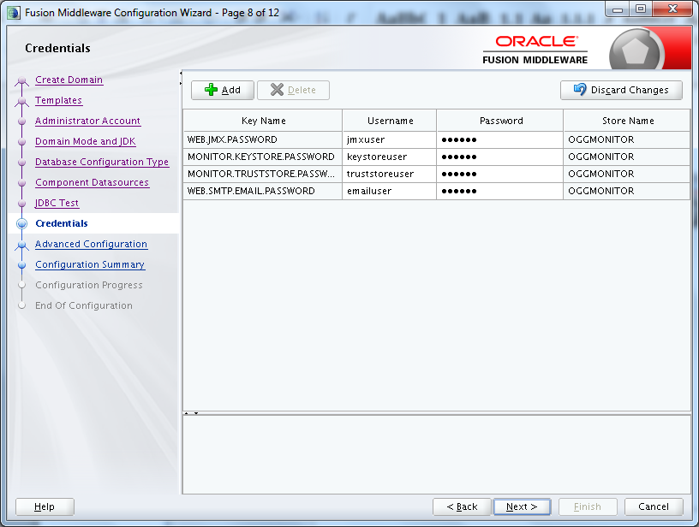

1. Select **Administrative Server** and **Managed Serves, Cluster, and Coherence**.
2. Click **Next**

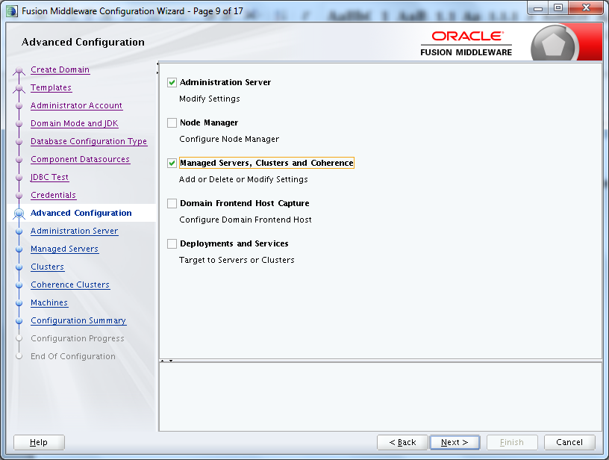

按需修改next

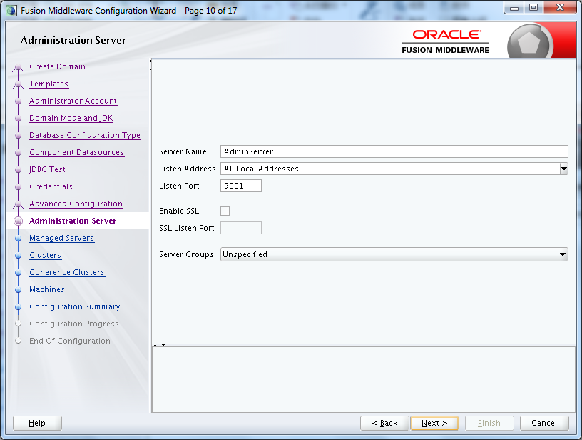

按需修改next

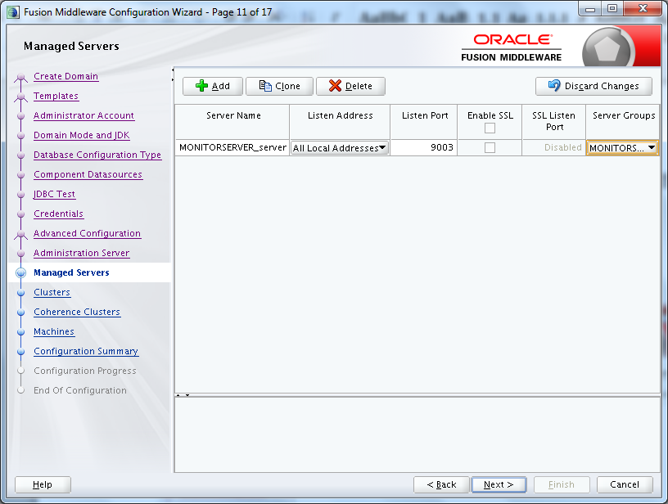

由于本实例使用单实例数据库无需配置 cluster, Next

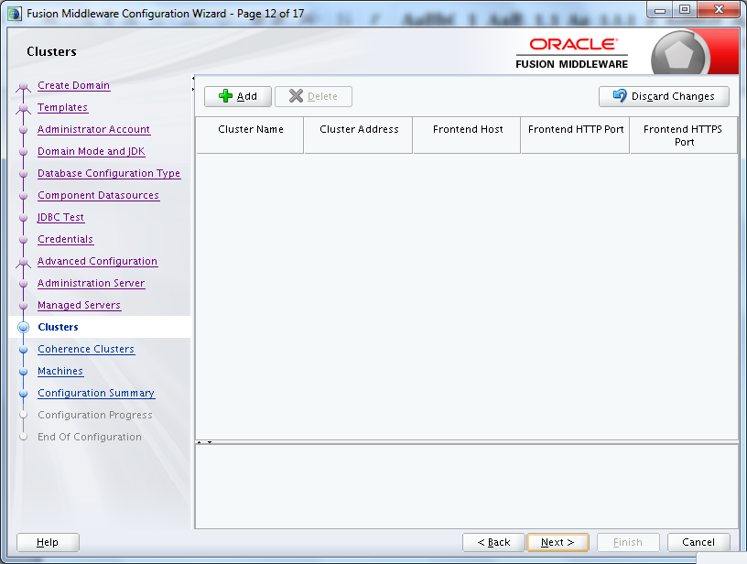

Next

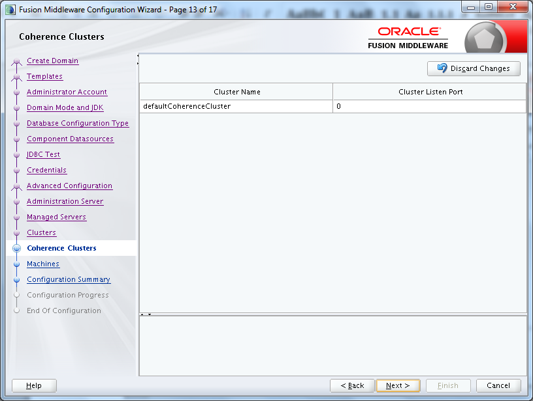

next

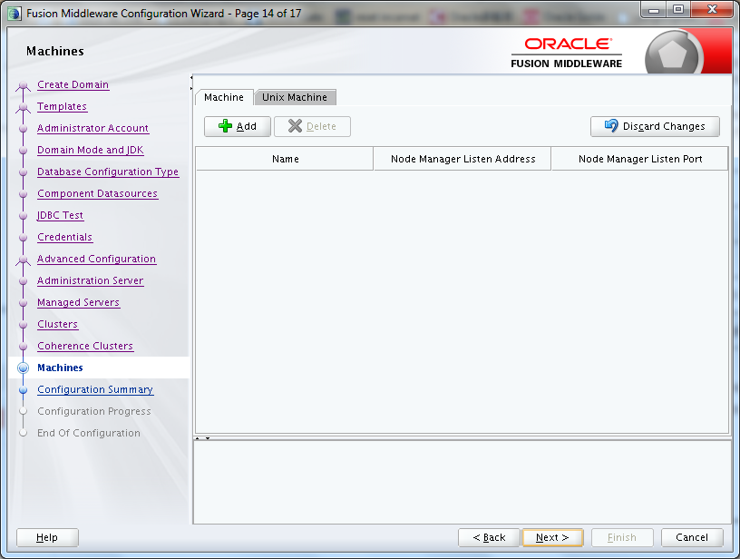

Review the configuration details and click **Create**.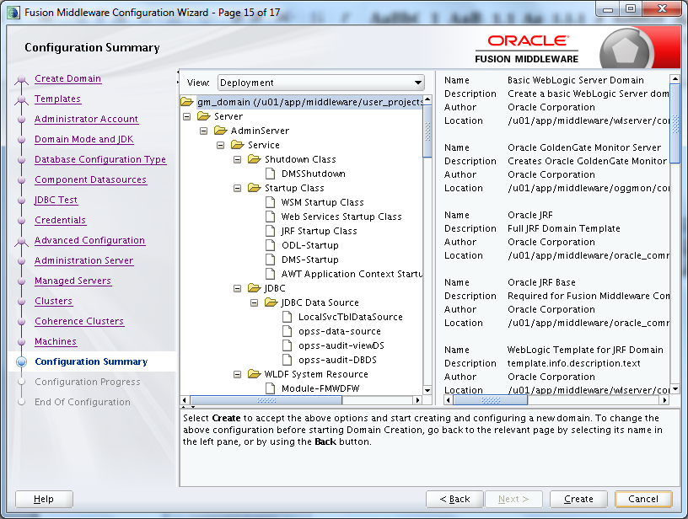

When configuration creation is complete, click Next.

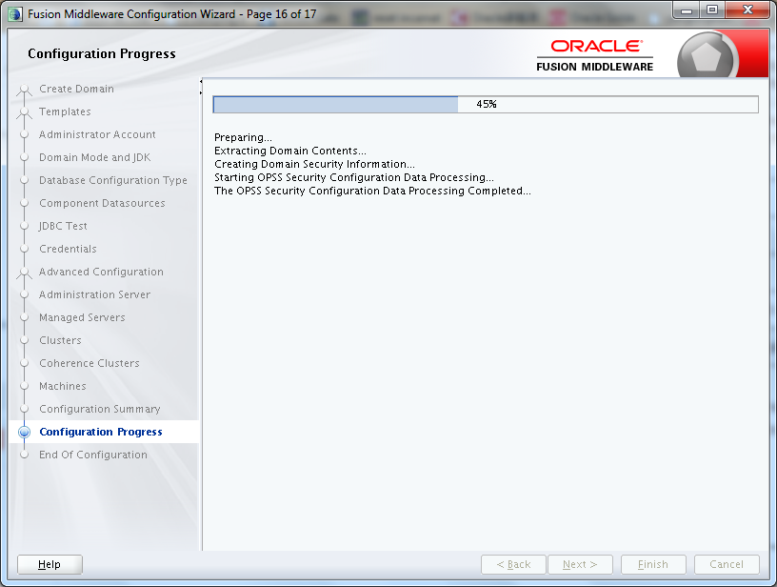

记录管理URL 点Finish

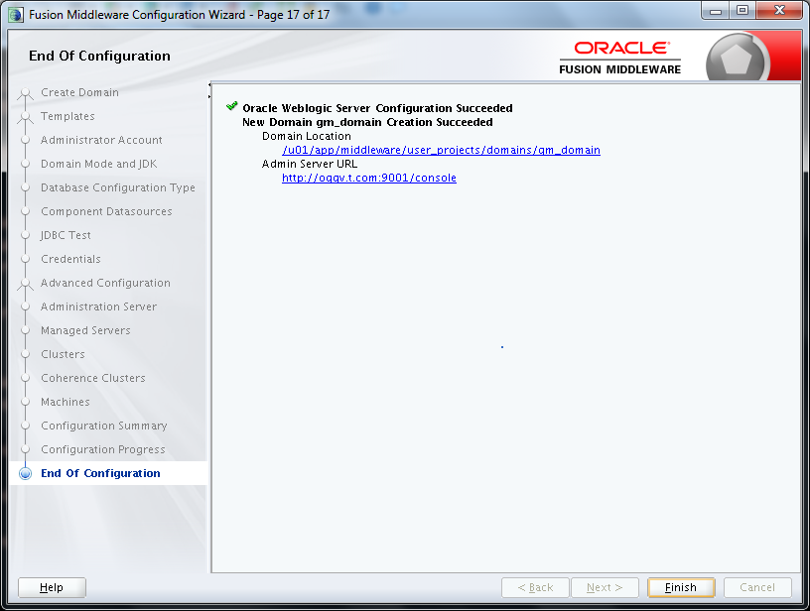

# 完成Monitor配置

## Configure the JMX Server Properties

$ cd $MW_HOME/oggmon/monitor_server/bin

$ ./updateOGGMonitorConfig.sh

## 输入domain的全路径

Enter absolute path for oggmon domain:

/u01/app/middleware/user_projects/domains/gm_domain

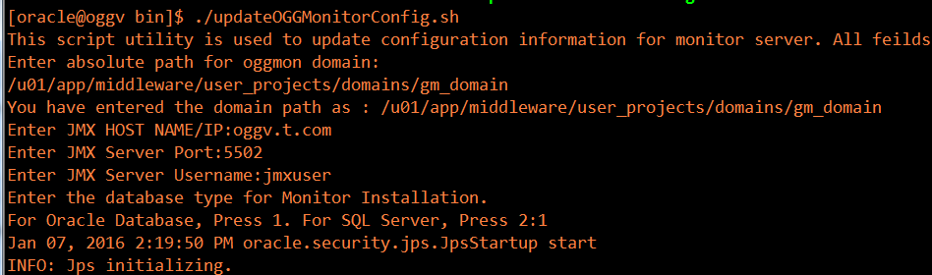

The utility completes. After successful execution of this script, the Secure Key properties file, oggmon.properties, is created in encoded format, and contains all of the configuration information you just provided. This Secure Key is added to your Oracle GoldenGate Monitor Server Oracle wallet.

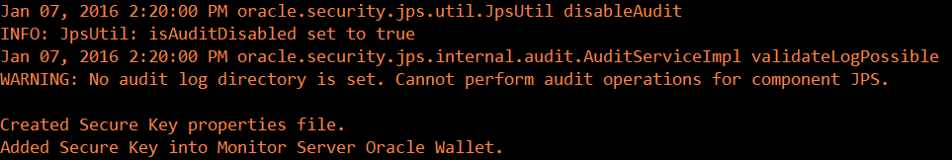

此功能生成oggmon.properties文件.

把文件 oggmon.properties 复制到agent 实例. 在GoldenGate Monitor Server,目录是 *$DOMAIN_HOME*/config/monitorserver/cfg;在 Monitor Agent上, 目录是$*AGENT_HOME*/cfg.

1. cd $DOMAIN_HOME/config/monitorserver/cfg
2. scp oggmon.properties agent_host:

# 检查配置并启动Weblogic&Monitor服务

## 启动Weblogic管理员服务器

Starting the Oracle WebLogic Administration Server

为了在后台启动Weblogic需要配置启动文件.

$ mkdir -p $DOMAIN_HOME/servers/AdminServer/security

$ echo "username=weblogic" > $DOMAIN_HOME/servers/AdminServer/security/boot.properties

$ echo "password=Password1" >> $DOMAIN_HOME/servers/AdminServer/security/boot.properties

启动weblogic admin server，用户名：weblogic 密码：Password1 (oracle 用户启动)

$ cd $DOMAIN_HOME

./startWebLogic.sh &



lsof |grep $DOMAIN_HOME/servers/AdminServer/tmp/AdminServer.lok

停止的话就找到进程杀之.

# 创建gg monitor专用用户

登录weblogic

<http://ip:9001/console> (如果不能访问，先确定iptables 有没有关闭)

weblogic/Password1

登录后选择：安全领域，选择myrealm

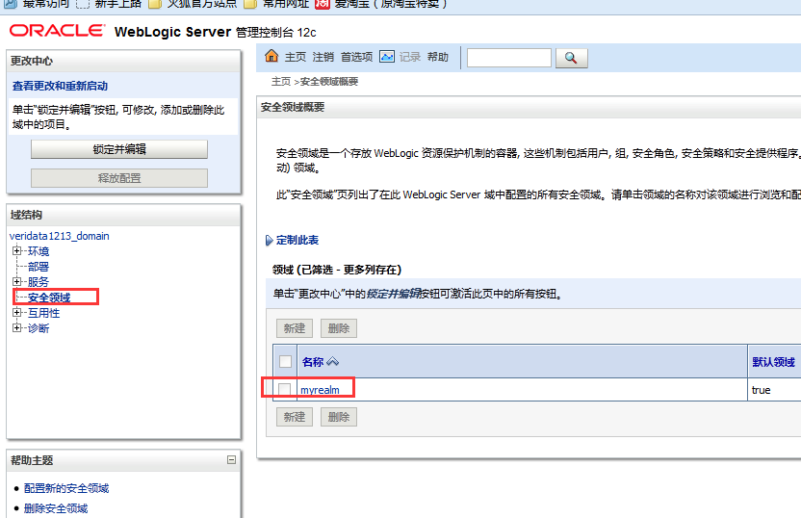

点击用户和组，新建用户

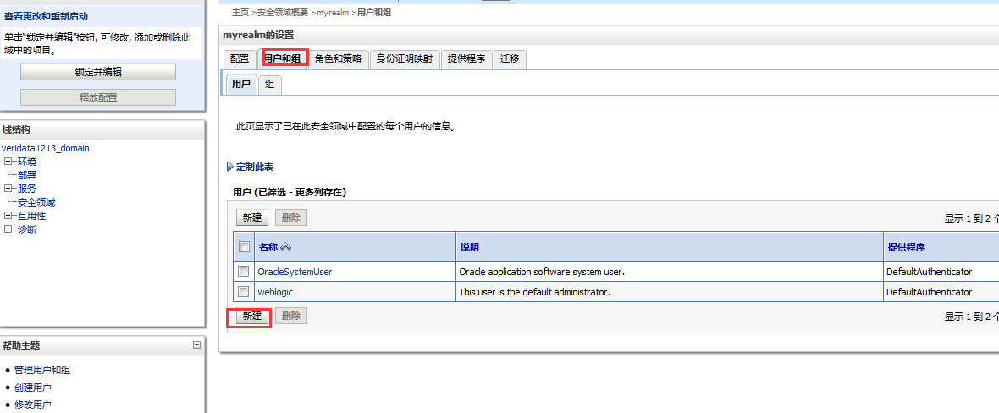

用户名/密码 : gm_admin/Password1如图点确定

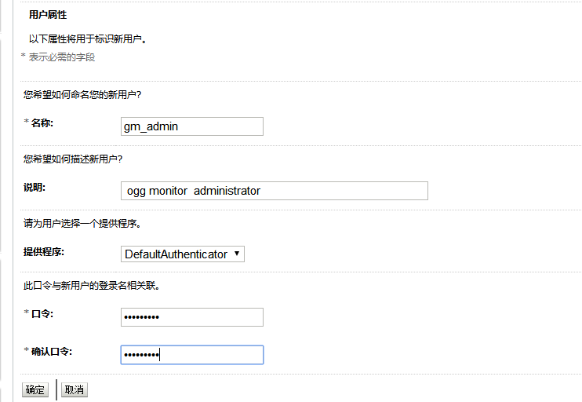

修改用户属组

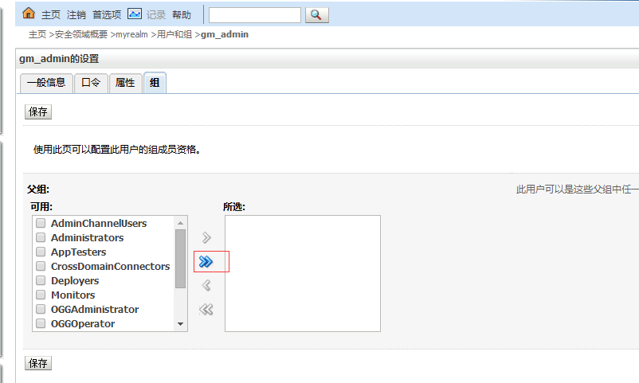

选择全部

# 启动Weblogic托管服务

Start the WebLogic Managed Server

$ cd $DOMAIN_HOME/bin

$ vi startManagedWebLogic.sh

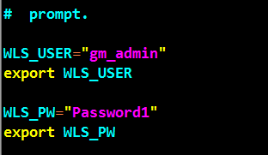

启动之前调整内存

$ vi setStartupEnv.sh

找到

# Startup parameters for STARTUP_GROUP MONITORSERVER-MANAGED-SERVERS

然后修改红色部分 如图所示

# 64 bit JVM memory settings

SERVER_MEM_ARGS_64="-Xms256m -Xmx1024m"

export SERVER_MEM_ARGS_64

SERVER_MEM_ARGS_64HotSpot="-Xms256m -Xmx4096m"

export SERVER_MEM_ARGS_64HotSpot

SERVER_MEM_ARGS_64JRockit="-Xms256m -Xmx1024m"

export SERVER_MEM_ARGS_64JRockit

$ ./startManagedWebLogic.sh MONITORSERVER_server1 http://ip:9001 &

进入gg monitor web页面: http://10.9.0.136:9003/monitor

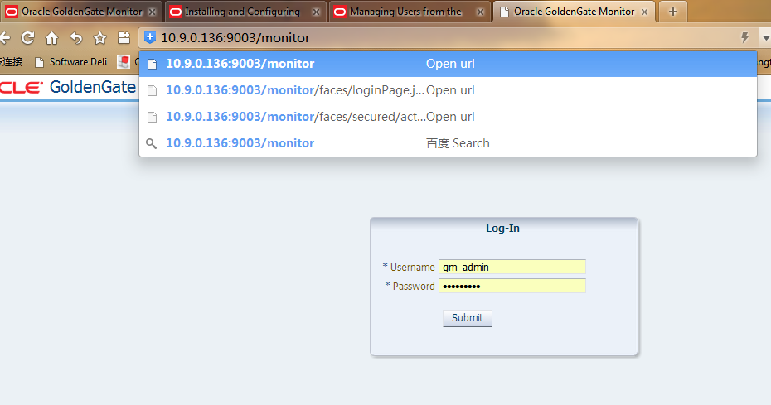

# 修改domain端口(可选项)

如果需要可以修改默认端口

$ cd $DOMAIN_HOME/config

$ vi config.xml

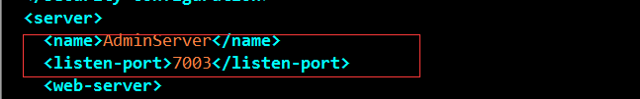

在第一个AdminServer下面增加

<listen-port>*合适的端口*</listen-port>

# 安装gg monitor agent

$ java -jar -Xmx1024m fmw_12.2.1.0.0_ogg.jar

省略简单步骤

1. Select **Oracle Golden Gate Monitor Agent**.
2. Click **Next**.

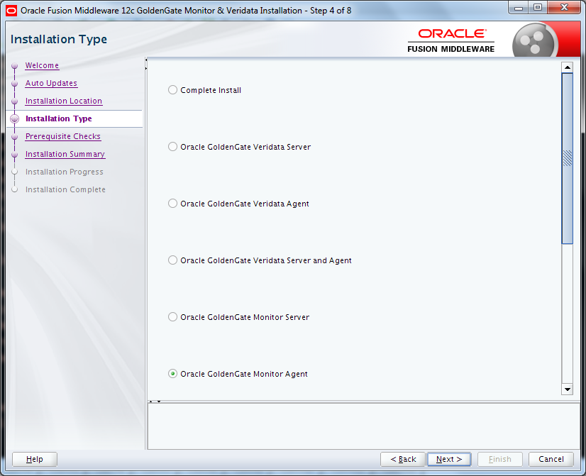

下面就是一路next 等等.

# 配置 monitor agent

## 创建agent实例

$ cd /u01/app/middleware/oggmon/ogg_agent

$ ./createMonitorAgentInstance.sh



## 修改配置文件

$ cd ~/gm_agent/cfg

$ vi Config.properties

<http://docs.oracle.com/goldengate/m1221/gg-monitor/GGAIN/inst_all.htm#GGAIN119>

绿色修改部分修改完成后如下

[oracle@oggs cfg]$ grep -v ^# Config.properties |sed -e '/^ *$/d'

jagent.host=oggs

jagent.jmx.port=5555

interval.regular=60

interval.quick=30

monitor.host=oggv.t.com

monitor.jmx.port=5502

monitor.jmx.username=jmxuser

jagent.username=jmxuser

reg.retry.interval=10

instance.query.initial.interval=5

incremental.registration.quiet.interval=5

maximum.message.retrieval=500

jagent.rmi.port=5559

agent.type.enabled=OGGMON

status.polling.interval=5

message.polling.interval=5

reg.retry.times=-1

jagent.backward.compatibility=false

jagent.ssl=false

jagent.keystore.file=jagentKeyStore

jagent.truststore.file=jagentKeyStore

jagent.restful.ws.timeout=15000

jagent.ggsci.timeout=30

## Create Wallet Credentials

$ scp oggv:/u01/app/middleware/user_projects/domains/gm_domain/config/monitorserver/cfg/oggmon.properties ./

$ cd /home/oracle/gm_agent/bin

$ ./pw_agent_util.sh -create

#密码全部 oracle

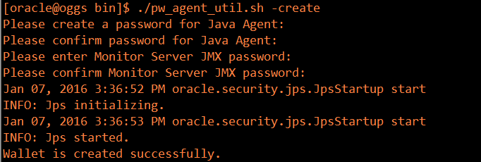

## 注册 agent instance

$ cd $GG_HOME

$ echo "ENABLEMONITORING" >> GLOBALS

$ ./ggsci

ggsci>create datastore

ggsci> stop mgr

ggsci> start mgr

ggsci> start jagent

必要时对ext,rep进程进行重启

过一段时间看到实例已经注册到gg monitor server上了

